CSE201 Advanced Programming

End-Semester Examination

Indraprastha Institute of Information Technology, Delhi

3rd December, 2023

Duration: 10:30 pm - 12:00 pm

**Marks: 35**

**Exam Requirements**

* Phones and other network sources are strictly prohibited. Invigilators will monitor available networks, and cheating will result in removal from the examination hall and award of F grade in the course.
* Keep your screen focused on the IDE during the exam. Any deviation will be regarded as misconduct and an appropriate action will be taken immediately.
* Your code must compile to receive any marks.

**Submission Guidelines**

* Name your final folder as **<RollNo>_<Name>.zip**. Failure to follow this naming convention will result in a score of zero.
* Create **separate sub-folders** inside the main folder **for each question**, naming them as Question_1, Question_2, etc.
* Please submit your **.java files** inside the sub-folder corresponding to the question.

**Note: No need to submit pom.xml files.**

**Please follow the good programming practices given below.**

* All the fields in the class should be private unless there is a good reason to have otherwise.
* A field should have a getter and a setter in general.
* All the methods of a class should be public unless there is a good reason to have otherwise (for example, helper methods need not be public).
* Follow the naming conventions for classes, fields, methods and objects. Classes and interfaces should follow the upper camel case (eg., RotateAndFly). Fields, methods and objects should follow the lower camel case (eg., fullName).

**Please make sure your code compiles. Zero marks will be given in case of compilation error.**

**We will be testing the submissions on ChatGPT specific plagiarism detectors also. In case any plagiarism case is detected, it will be dealt with as per IIITD plagiarism policy and without any relaxations.**

**Submission Link: https://forms.gle/M8xG71Y3ViCUQ5rv7**

**________________________________________________________________________________________**

Q1) Two arrays of integers are given in separate text files, A1.txt and A2.txt, as shown below. Considering those arrays as vectors, compute their two possible outer products and save the results in separate text files, A1XA2.txt and A2XA1.txt. Write a program to perform the task. **NOTE:** Take care of exceptions that can arise. While saving the matrices in text files, you can use either space or comma to separate the elements in a row.

| File Name | A1.txt | A2.txt |
| --- | --- | --- |
| Contents | 0  1  2  3  4  5 | 5  6  7  8  9 |

Outer Product Definition:

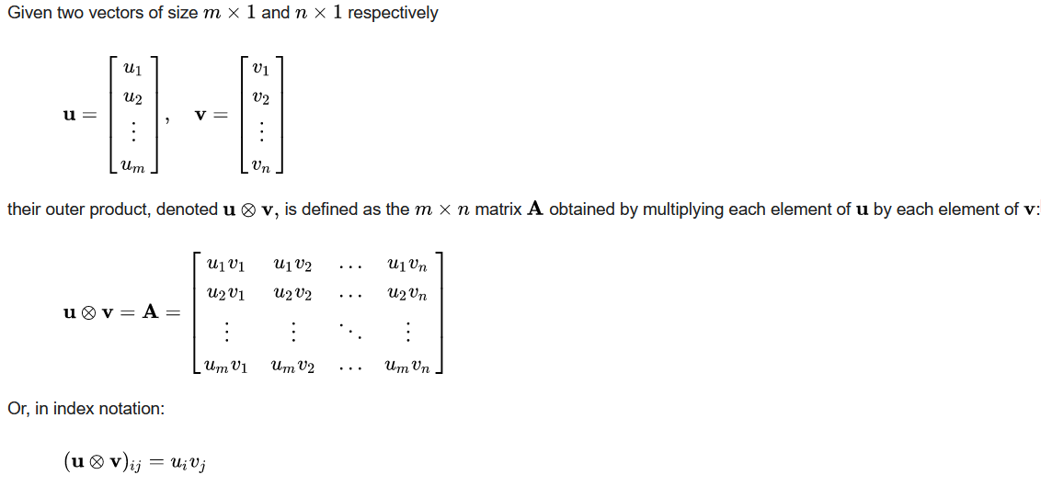

Q2) Create a class that can store either two Strings or two Integers as its data members. It should have a function that concatenates the two data members and returns the result as a String. **NOTE:** Your driver class must demonstrate the workings of both the cases.